1. A -> B-C | C

B -> C | dAe

C -> fg | C+A

1. Go To

0 A’ 🡪 A

1 A 🡪 . B-C

3 A 🡪 . C

4 B 🡪. C

5 B 🡪 .dAe

6 C 🡪 . fg

7 C 🡪 . C+A

1. Follow

Follow A

1. B 🡪 dAe = First(e) = {$, e}

Follow B

1. A 🡪 . B-C = First(-) = {-}

Follow C

1. A 🡪 . B-C = Follow(A) = {$, e}
2. A 🡪 . C = Follow(A) = {$, e}
3. B 🡪. C = Follow(B) = {-}
4. C 🡪 . C+A = First(+) = {+}
5. Total = {e, -, +}
6. SLR Scheme Diagram & Table

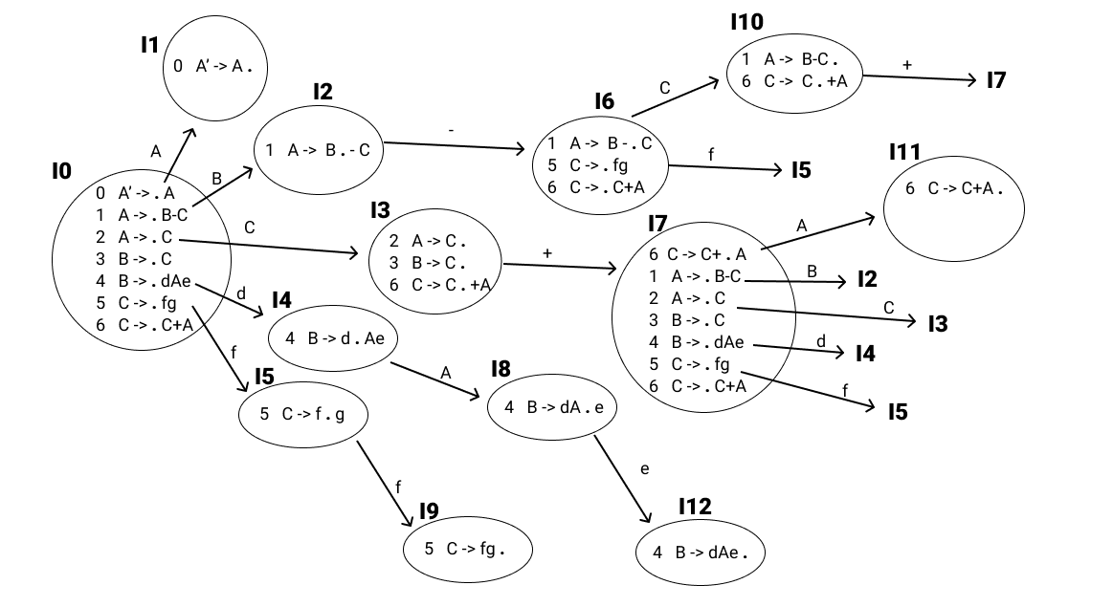

|  |  |  |  |  |  |  |  |  |  |  |
| --- | --- | --- | --- | --- | --- | --- | --- | --- | --- | --- |
|  | - | d | e | f | g | + | $ | A | B | C |
| 0 |  | S4 |  | S5 |  |  |  | 1 | 2 | 3 |
| 1 |  |  |  |  |  |  | accepted |  |  |  |
| 2 | S6 |  |  |  |  |  |  |  |  |  |
| 3 | R3 |  | R2 |  |  | S7 |  |  |  |  |
| 4 |  |  |  |  |  |  |  | 8 |  |  |
| 5 |  |  |  | S9 |  |  |  |  |  |  |
| 6 |  |  |  | S5 |  |  |  |  |  | 10 |
| 7 |  | S4 |  | S5 |  |  |  | 11 | 2 | 3 |
| 8 |  |  | S12 |  |  |  |  |  |  |  |
| 9 | R5 |  | R5 |  |  | R5 |  |  |  |  |
| 10 |  |  | R1 |  |  | S7 |  |  |  |  |
| 11 | R6 |  | R6 |  |  | R6 |  |  |  |  |
| 12 | R4 |  |  |  |  |  |  |  |  |  |

1. Input = df-fe

|  |  |  |
| --- | --- | --- |
| STACK | INPUT | ACTION |
| **0** $ | **d**f-fe | S4, push (d), push(4) |
| **4**d0 $ | **f**-fe | **REJECTED** |

1. X -> Yb | X-Y | Z

Y -> Za |X+Z

Z -> a

* 1. GoTo

X’ -> . X

1 X -> . Yb

2 X -> . X-Y

3 X -> . Z

4 Y -> . Za

5 Y -> . X+Z

6 Z -> . a

* 1. Follow

Follow X

1. Start = {$}
2. X -> X-Y = First(-) = {-}
3. Y -> X+Z = First(+) = {+}
4. Total = {$, -, +}

Follow Y

1. X -> X-Y = Follow (X) = {$, -, +)
2. X -> . Yb = First (b) = {b}
3. Total = {$, -, +, b}

Follow Z

1. X -> Z = Follow (X) = {$, -, +}
2. Y -> X+Z = Follow (Y) = {$, -, +, b}
3. Y -> . Za = First (a) = {a}
4. Total = {$, -, +, b, a}
   1. SLR Scheme Diagram & Table

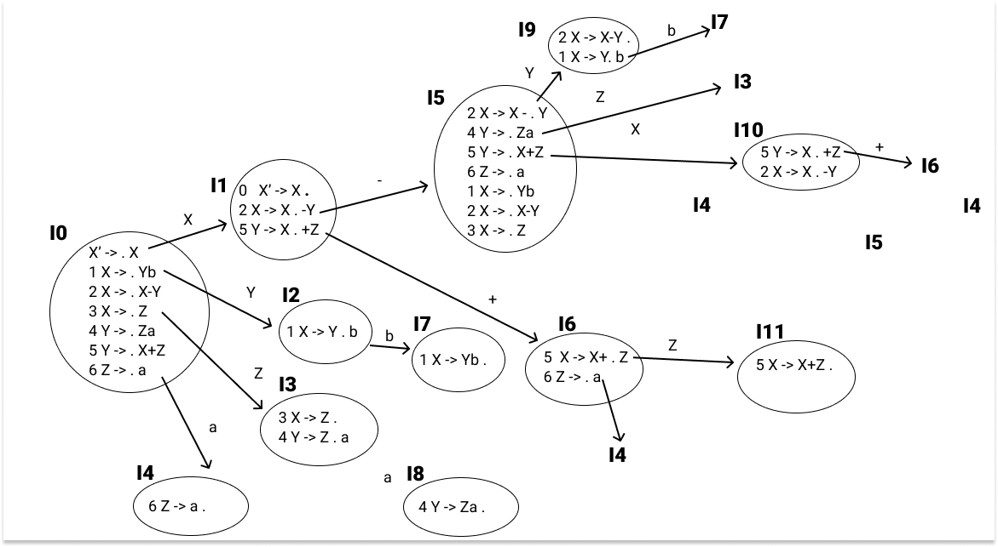

|  |  |  |  |  |  |  |  |  |
| --- | --- | --- | --- | --- | --- | --- | --- | --- |
|  | a | b | + | - | $ | X | Y | Z |
| 0 | S4 |  |  |  |  | 1 | 2 | 3 |
| 1 |  |  | S6 | S5 | Accepted |  |  |  |
| 2 |  | S7 |  |  |  |  |  |  |
| 3 | S8 |  | R3 | R3 | R3 |  |  |  |
| 4 | R6 | R6 | R6 | R6 | R6 |  |  |  |
| 5 | S4 |  |  |  |  | 10 | 9 | 3 |
| 6 | S4 |  |  |  |  |  |  | 11 |
| 7 |  |  | R1 | R1 | R1 |  |  |  |
| 8 |  | R4 | R4 | R4 | R4 |  |  |  |
| 9 |  | S7 | R2 | R2 | R2 |  |  |  |
| 10 |  |  | S6 |  |  | 5 |  |  |
| 11 |  |  | R5 | R5 | R5 |  |  |  |

input = aab+a

|  |  |  |
| --- | --- | --- |
| STACK | INPUT | ACTION |
| **0** $ | **a**ab+a $ | S4, push (a), push(4) |
| **4**a0 $ | **a**b+a $ | R6, Z -> a |
| **Z0** $ | ab+a $ |  |
| **3**Z0 % | **a**b+a $ | S8, push (a), push(8) |
| **8**a3Z0 % | **b**+a $ | R4, Y -> Za |
| **Y0** % | b+a $ |  |
| **2**Y0 $ | **b**+a $ | S7, push(b), push(7) |
| **7**b2Y0 $ | **+**a $ | R1, X -> Yb |
| **X0** $ | +a $ |  |
| **1**X0 $ | **+**a $ | S6, push(+), push(6) |
| **6**+1X0 $ | **a** $ | S4, push (a), push(4) |
| **4**a6+1X0 $ | **$** | R6, Z -> a |
| **Z6**+1X0 $ | $ |  |
| **11**Z6+1X0 $ | **$** | R5, Y->X+Z |
| **Y0** $ | $ |  |
| **2**Y0 $ | **$** | **REJECTED** |
|  |  |  |
|  |  |  |
|  |  |  |
|  |  |  |
|  |  |  |